**Home Equity Reverse Mortgage Information Technology**

**(HERMIT)**

**HERMIT System Changes – Release 5.3**

**Release Date: 03/04/17**

**Document Date: 03/02/17**

March 2017

Version 1.0

**INTRODUCTION**

The Home Equity Conversion Mortgage Service Provider (HECM SP) has released version 5.3 of the Home Equity Reverse Mortgage Information Technology (HERMIT) software which consists of:

1. System requires the appropriate loan number field to be populated in order to complete CT 22 timeline step “Submit Assignment Request to HUD” which is reflected in Block 14 on the Claim Form
2. Prevent certain changes on Claim Type 21, 23, and 24 after Claim is submitted to HUD
3. Allow certain user roles to access Accounting search screens
4. Additional changes to Block #121c on CT24
5. Update Assignment Checklist in the Endorsed CT-22 Assignment Timeline

If you have any questions regarding the functionality of the software release, please contact the HERMIT Help Desk at 561-899-2610 or at [servicingsupport@hermitsp.com](mailto:support@hecmsp.com). If you have any policy related questions, please send an email to HUD at [answers@hud.gov](mailto:answers@hud.gov).

## System requires the appropriate loan number field to be populated in order to complete CT 22 timeline step “Submit Assignment Request to HUD” which is reflected in Block 14 on the Claim Form

## The purpose of this topic is to add a system check that the appropriate field needed for Block 14 of the claim form is populated prior to the Assignment Request being submitted to HUD. In addition, additional verbiage was added to the existing Certify message that is displayed when the “Submit Assignment Request to HUD” step is completed.

* + 1. The new validation occurs on the CT 22 timeline at the step “Submit Assignment Request to HUD”. This will prevent the servicer from requesting HUD to issue Preliminary Title approval for an Assignment claim when information that populates Block 14 on the claims worksheet is missing. The existing validation that occurs when the claims worksheet is filled out and the claim is submitted to HUD will remain in place.

**Note:** Finalizing and submitting the claims worksheet completes the timeline step “Assignment to HUD sent for recording/Servicer Files Claim Type 22 - Form 27011”.

The following validation rules must be met in order to complete the timeline step “Submit Assignment Request to HUD”. The appropriate field must be populated based on the current investor:

1. Investor Fannie Mae: Investor Loan # field
2. Investor Ginnie Mae: Ginnie Mae # field
3. Investor All other investors: Lender Loan # field

If the necessary loan number field is blank, the system will display an error message and prevent the timeline step from being completed until the field is populated.

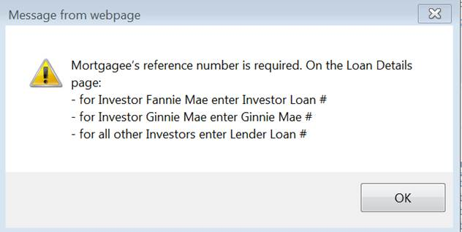

Figure 1: “Submit Assignment Request to HUD” step Error Message

Authorized user roles can enter the missing information in the Loan > Loan Details > Loan Identifiers section.

* + 1. Verbiage was added to the existing certify message that is displayed when the timeline step “Submit Assignment Request to HUD” is completed. The added verbiage is:

“This claim is being submitted to HUD for review and approval. Claim funds are disbursed to the Investor (Holder). Are you sure the Investor (Holder) shown on this loan is correct? Click ‘YES’ to continue or ‘NO’ to cancel.”

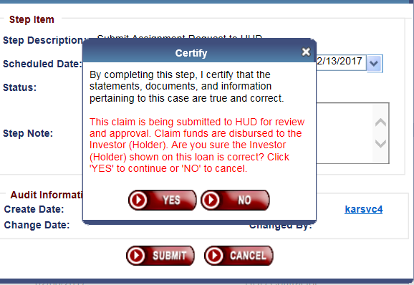

Figure 2: Updated Certify message

## Prevent certain changes on Claim Type 21, 23, and 24 after Claim is submitted to HUD

The purpose of this topic is to prevent changes to transactions, documents, and timeline status on Claim Types 21, 23, and 24 after a claim is submitted by the servicer.

* + 1. The system will prevent transactions from being added or adjusted during HUD’s claim review process. HUD’s claim review process begins when the timeline step “Servicer Files Claim – 27011” is completed (indicating the claim is submitted by the servicer to HUD). If HUD returns the claim to the servicer, transactions may be added or adjusted until the claim is resubmitted to HUD.
       1. During HUD’s claim review process, the buttons will not be displayed on the Transactions screen. This includes but is not limited to “New”, “Balance Adj.”, “IMIP Adjustment”, and “Write Off” buttons on the Transactions > Loan screen, as well as the “New” button on the Transactions > Set Aside screen.
       2. During HUD’s claim review process, the Adjustment notepad icon will not be displayed next to each transaction.
       3. This restriction applies to all methods of transaction entry such as the Loan > Transactions screen in the User Interface, B2G files, and Batch > Servicer transactions.

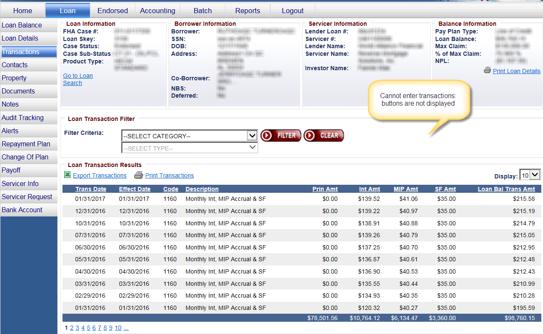

**Figure 3: Editing transactions is restricted**

* + 1. The system will prevent documents from being deleted after the timeline step “Servicer Files Claim – 27011” is completed.
       1. After a claim is submitted, the Delete icon will not be displayed next to each document.

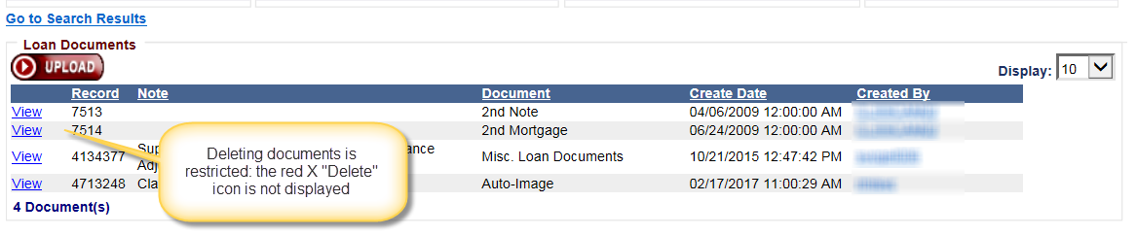

**Figure 4: Deleting documents is restricted**

* + 1. The system will prevent CT21, CT23 or CT24 timelines from being changed to Inactive after the timeline step “Servicer Files Claim – 27011” is completed. If HUD pends the claim back to the servicer, the timeline can be inactivated until such time that the claim is resubmitted.

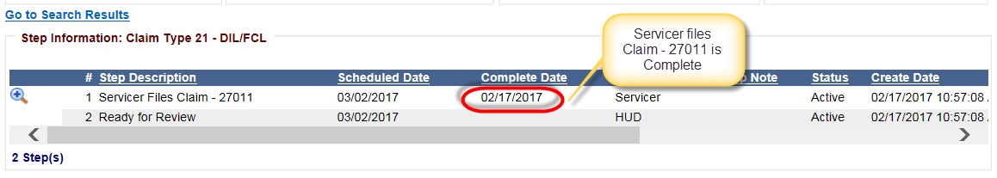

**Figure 5: Claim Filed by servicer**

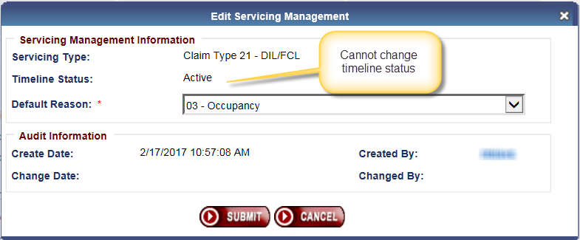

**Figure 6: Changing Timeline status is restricted**

## Allow certain user roles to access Accounting search screens

The Single Family Claims Branch (SFCB) previously provided investors with a report pulled from the Accounting > Claims screen in HERMIT. Permissions have been updated to grant access to this screen to Investor Read only and Servicer user roles and these reports are available to be pulled directly by the authorized users. In addition, access to Accounting > Transmittals has been granted to servicer user roles.

* + 1. The following user roles now have access to the Accounting > Claims screen

1. Investor Read Only
2. Servicer Manager
3. Servicer Staff
4. Servicer Read Only

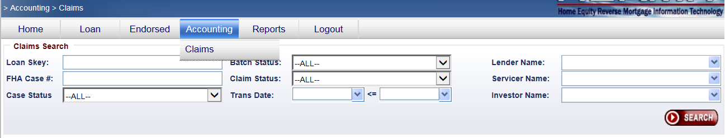

**Figure 7: Accounting > Claims Search**

* + 1. The following user roles now have access to the Accounting > Transmittals screen
       1. Servicer Manager
       2. Servicer Staff
       3. Servicer Read Only

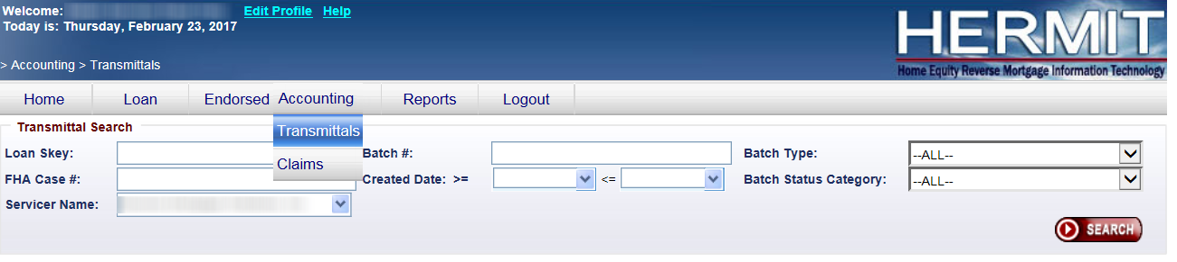

**Figure 8: Accounting > Transmittals Search**

## Additional changes to Block #121c on CT24 30142 545361

The purpose of this topic is to update Block #121c to clarify MCA cap for Expenses and Debenture Interest on Expenses.

* + 1. Expenses are capped at any remaining MCA from parent claim. If the MCA was exceeded on the parent claim, no additional expenses will be paid on the CT24. The expense amount payable is displayed on the AOP in the “Expenses” field and any expense not paid will show up in AOP field “Adjustment to Outstanding Balance”.
    2. Expense DBI is included in the AOP “Expenses” field and is not capped at MCA. The Expense DBI amount is calculated by HERMIT and the allowable amount is automatically added to the claim.
    3. Block #121c is included in the AOP “Expenses” field and is not capped at MCA.
* **Important Note**: do not add the UPB DBI or Expense DBI amounts to Block #121c as these are calculated by HERMIT and the allowable amount is automatically added to the claim.

## Update Assignment Checklist in the Endorsed CT-22 Assignment Timeline

The purpose of this topic is to add and change descriptions on the CT 22 Assignment Checklist used by the HUD NSC.

## Changes to Collateral Package Checklist

* + - 1. Added new task “Evidence Mobile Home Title has been retired (if applicable)”.
      2. Updated description to “Correct Effective Date? (same as recorded date of Deed of Trust or shortly before or after?). The description previously read “Correct Effective Date? (same as recorded date of Deed of Trust or shortly thereafter?)”.
      3. Updated description to “Proper Insurance Amount (equal or greater than Max Claim Amount?)”. The description previously read “Proper Mortgage Amount (equal or greater than Max Claim Amount?)”

## Changes to MOE Assignment Checklist

* + - 1. Added new task “Assignment Initiation: Verify create date of Assignment timeline is within 120 days from date of MOE Election Letter from Mortgagee”

If Yes, then proceed with Assignment Review Yes

If No, deny Assignment Request No

* + - 1. Updated description to “MOE Election Letter from Mortgagee – Verify date of MOE Election letter is within 120 days from the death of the last surviving HECM borrower or within 120 days from 6/12/2015, whichever is later”. The description previously read “MOE Election Letter from Mortgagee - Verify date of MOE Election letter is within 30 days from the death of the HECMborrower or within 120 days from 06/12/2015”.
    1. Change to Servicing Package Checklist: Added new task “Copy of Complete Loan Agreement” with checkboxes for Acceptable and Unacceptable.